[Document Title]

[Date in *DD Month YYYY* format]

[Version X.Y]



Table of Contents

A. Document History 4

B. Document Scope 5

**List of Figures**

Figure 1: Original document map. 1

# Document History

|  |  |  |  |  |
| --- | --- | --- | --- | --- |
| Relevant Sections | Version | Date | Changes | Author |
| Entire Document | 1.00 | 09/20/2011 | Baseline | XSEDE |
|  |  |  |  |  |
|  |  |  |  |  |
|  |  |  |  |  |
|  |  |  |  |  |

# Document Scope

[Define the scope of this document and any instructions on how to read it.]

# [Document Body]

This is where the meat goes….

This is a reference to Figure 1 for template purposes….

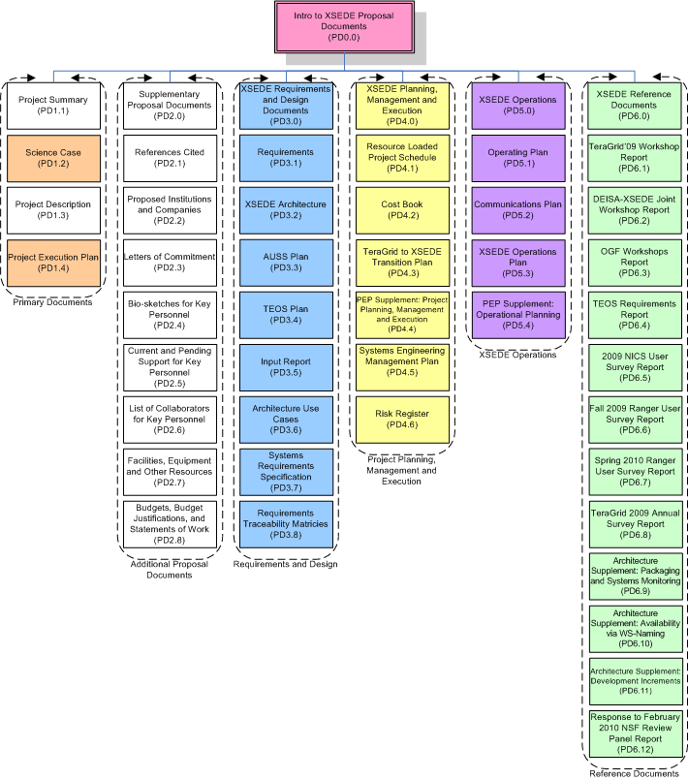

Figure 1: Original document map.

And more meat here…..